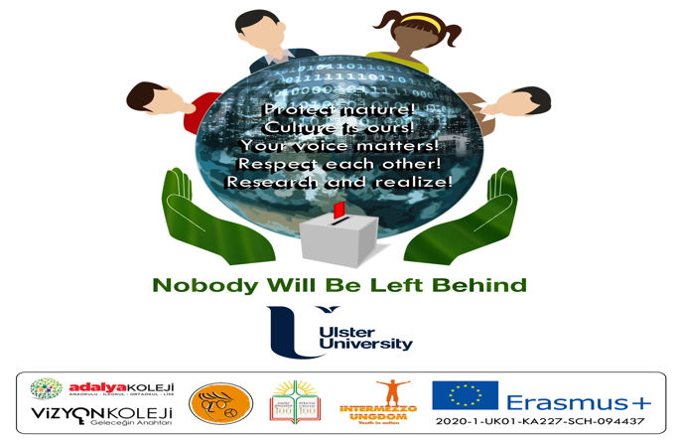

Promoting Citizenship Awareness amongst Young People in Europe using Education

European Youth and Culture Club Evaluation
[INSERT Partner Name]
[INSERT PARTNER LOGO]

Contents

- Overview of European Youth and Culture Club use in your school

- Feedback from young people who were part European Youth and Culture Clubs

- Challenges engaging families and young people in European Youth and Culture Clubs

AIMS AND OBJECTIVES OF THE CURRENT REPORT

In this national report, we will capture how young people and families have engaged with the European Youth and Culture Clubs in your school and how effective this has been. The clubs are a key output of this project to help increase awareness and deliver citizenship education and this reports allows an opportunity to present feedback on use.

- Overview of European Youth and Culture Club use in your school
  - This should provide details on how many young people and families engaged with this activity. The target for each school is 20 families and 50 young people.
- You should also comment on how well this was achieved and why?

- Feedback from young people who were part European Youth and Culture Clubs
Qualitative feedback from young people who used the European Youth and Culture Clubs as in testimonials. This is an opportunity to reflect in the young people’s own words how enjoyable, impactful, inspiring and beneficial the clubs were. Please include at least 5 testimonials.

3. What challenges did you face engaging families and young people in the European Youth and Culture Clubs
If no challenges then note ‘None’. If you found good practice that worked well then please share with other partners through this report.

