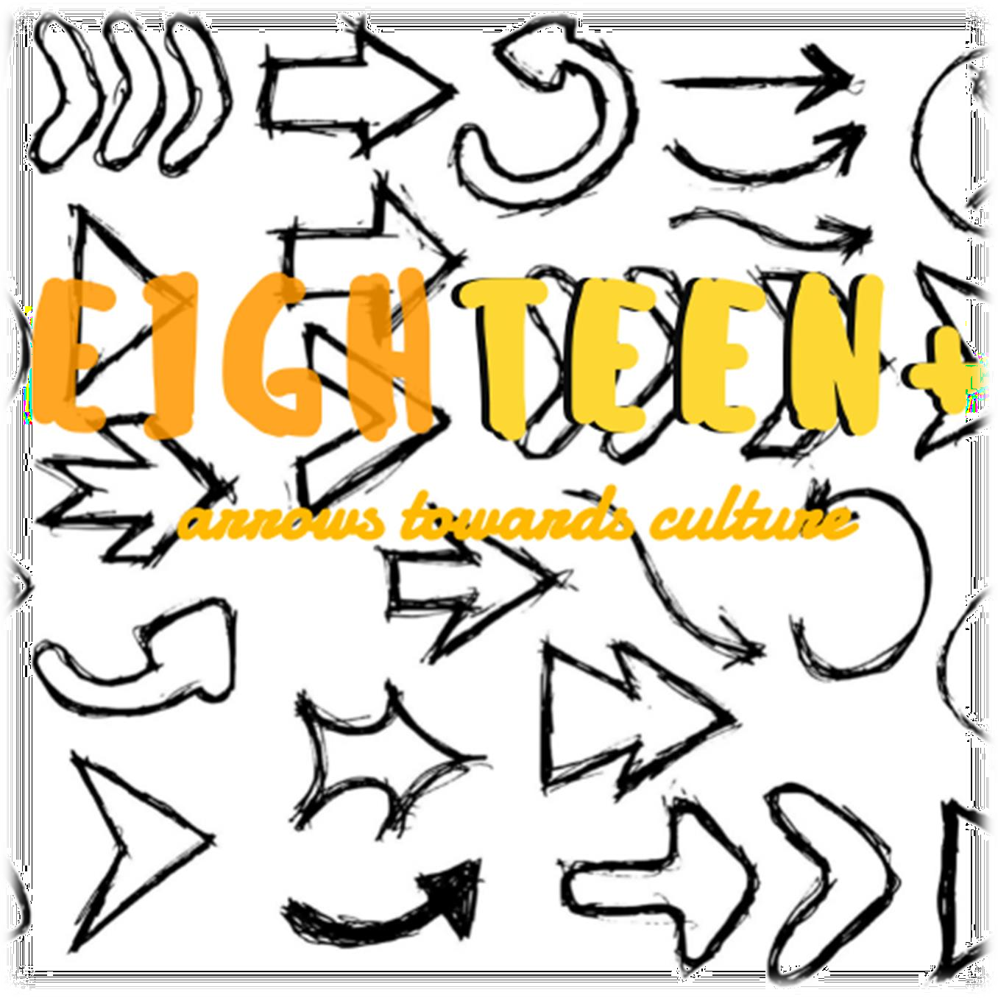

INTRODUCTION

Culture.

A word commonly used, containing infinite meanings and nuances. Let’s talk about culture.

It can be extremely complex, as it includes undefined facets, on the place, the time and the people you relate to.

From the latin *colere*, "to cultivate", it indicates the set of intellectual knowledge, acquired through study and experience, subjectively reworked to enrich the spirit and to improve the abilities of the individual within the community.

Spreading the culture.

The club EIGH**TEEN**+ (arrows towards culture) is committed to breaking down prejudices and enhancing the attitudes of young people, through the dissemination of the social principles that characterize their traditions, accompanying them in the streets through which children wish to walk, and through projects and meetings that allow them to meet.

In particular, EIGH**TEEN**+ has identified eighteen different routes, hence the name that characterizes it but does not limit it. The choice, in fact, to add "+" is not random: culture is in everything you look at. Because the possible directions are multiple and they range in numerous fields, the club’s desire is to integrate as many inclinations, characteristics and passions as possible.

* Literature: as ideas advocate and information fomenter, it influences expressions, thoughts and, unknowingly, changes human beings
* Music: with sweet notes and entrancing melodies, it inspires poets, enhances feelings and creates emotions
* Cinema: the expression of human reality observed in a different way, suitable for every genre and perfect for every eventuality
* Craftsmanship: with meticulous detail and care, it is a skillful ally of beauty, it captures the particularity of a place, an object, a being
* Territorial configuration: through nature and environment, it influences stories and the needs of peoples
* History: timeless narrator of victories and defeats, stories of men, slaves and masters, authors of success and failures
* Artistic heritage: sculpture, painting and architecture, inestimable and inexhaustible source of gratitude and amazement towards the magnificence of the human intellect.
* Folklore: myths and legends tell of lethal creatures, the right balance between fear and adventure. To believe in it you need only a pinch of madness
* Fashion: world of luminescent colours, a vortex of creativity and innovation, where the only revered god is the charm
* Dance: union between poetry and revolution, inner ocean of splendour and light
* Languages: rhythm and vivacity, distinctive trait of the individual and the community
* Education: exclusive source of freedom for anyone who is about to approach it. Knowledge is power!
* Photography: a way to capture and make eternal a moment, a truth imprinted on paper that has the ability to excite, although exceptionally concrete , an image captured
* Sport: an element of cohesion and adherence. It helps friendship and teaches respect
* Somatic aspect: distinctive feature and evidence of a people not underestimated. People who do not believe in mutual respect and affection between human beings only as such, and that make somatic peculiarities, such as the colour of the skin or the shape of the eyes, a fault, leaving out that they should simply be a boast, as an expression of human evolution
* Typical dishes: means to combine the useful with the pleasant. Choose typical and tasty recipes, pills of history “baked in the oven”, make people joyful and happy to eat with pleasure
* Traditions and recurrences: methods that have always been used by man to celebrate an anniversary, but which are simply just an excuse to stay together and to honor the joy

Point I: Intentions

* Fostering international exchanges of cultures and traditions
* Breaking down the walls of prejudice and destroying clichés
* Creating a climate of harmony between the various European ethnic groups in order to create a cohesive and respectful society
* Encouraging a multi-ethnic community for the future
* Improving the judgment of young people to enable them to be men and women succeed and open to change

Point II: Members

Every European teenager (12-20 years old) has the opportunity to join EIGHTEEN+. Registration for the club must be accompanied by a document (videos, photos, texts, recipes, music tracks, artistic production and other) produced by the person who wishes

to enroll. Each testimony collected is inserted within a dedicated section in the official website of the club, in order to make sure that everyone can contribute to the growth of the values of which EIGHTEEN+ is the spokesperson, giving a part of himself/herself and his/her knowledge.

Point III: Positions

* Each participating school freely chooses one means of culture identified by EIGHTEEN+, maybe the one it feels most represented by
* The club has smaller locations in each of the participating schools, which in case of internal problems can relate to the headquarters of the organization and administration

Point IV: officer duties

* President = he/she is at the basis of the organization of the club in each acceding State. For each country there is a different president, who is responsible for managing the respective heads of all the smaller offices, to plan the proposed initiatives, to be the first spokesperson of the promoted values and through its solid presence he/she encourages the team to work and young people to choose the culture around them;
* Vice President = he /she assists the President in the organization of the club, replaces him in case of need, andin meetings, assembly and conferences that do not require the presence of the President; he/she generates minute of the meetings held, he/she transcribes and organize the initiatives proposed by the club, he/she inform the heads of smaller venues about particular events or meetings arranged by leading leaders;
* Webmaster / Social Media Manager = he/she is responsible for creating an effective, attractive, organized and fast website (see point VII)¸ he/she is responsible for the social pages of the club, through the sharing of attractive information, photos, tweets, posts, stories and videos directly from the production of the members, to show effectively, easily what EIGHTEEN+ deals with;

Point V: Organisation of meetings

* The central committee will be composed of the President, Vice President, Social Media Manager. They are responsible for decisions relating to the internal organization of the club,
* The meetings will be convened by the President in the case one of the members of the Central Committee should raise a problem, or in more relevant cases, if the question is raised by one of the responsible persons.
* During the year, about every two/three months, the president will convene a meeting with in order to be informed about the progress of the club in the smaller venues, the participation and preferences of students
* The President and Vice President will always be available for any matter or problem.

Point VI: Activities

* ASKING FOR: this is a project that is based on an exchange of letters opened to all members of the club. Each participant has the opportunity to send a message, anonymously, to the website of the club containing a question (or more) about characteristics and traditions of a particular country; the answers are free and available to everyone, on a page open to the dialogue, to the considerations and the sharing.
* MEETING: during the course of that year each State is responsible for organizing meetings, virtual and non, to which all members of the association are invited to participate, aimed to promote the typical cultural features of the place, through lessons from specialist of the field.
* EUROPEANS OF CULTURE: every four years a big event is organized in the city chosen for that year, to which all members are invited. Each country is a candidate, the members of the Youth Club vote for a country. The event lasts several days. Through guided tours and excursions, people will have the opportunity to know the culture and the popular and historical tradition of the place. Tours can also be virtual in order to allow those who aren’t able to travel to “experience the sounds, the colors and the beauty” of another country.
* TIME TO TRY: “students become teachers” and make up videos to teach chunks of their language or ways of saying, to members from other countries. These videos will be uploaded on a special section of the website.
* 21 MAY: On 21st May, International Day of Culture, EIGHTEEN+ invites all members to demonstrate peacefully in public places in order to spread the EIGHTEEN+ community values
* GREEN PLACE: students are invited to prepare documents (videos, presentations..) in which they show green places and areas where the flora and fauna of their territory lives untouched despite the technological advancement of the last century.
* STRANGE NORMAL THINGS (podcasts, recipes, everyday life): it is a project based on interactive sharing of your everyday life. Each State, however obvious, has its own habits related to different lifestyles, for this reason the basic idea is to tell the "strange normal things", those little things that characterize our day but that for others can represent a novelty. It will be divided into three sections:
  1. Everyday life: this is a video in which everyone is free to film himself/herself and shows his/her culinary habits, a tradition typical of his/her country, a custom related to the means of transport, the configuration of the city and so on. All videos will be collected in a special section on the official website;
  2. Podcast: a podcast accessible to all through various platforms (such as spotify) where one or more students from each country, weekly, talk about musical trends in their state: ranking of the most listened songs, hits of the moment, most appreciated bands, relevant genre and so on;
  3. Recipes: this is a section on the website dedicated to culinary peculiarities from different places in Europe. Anyone who wants can resume the preparation of a recipe typical of his/her place and publish it on the official page of EIGHTEEN+ that will be accessible to all, in order to feel the others and their culture increasingly closer in an easy and good way.
* FILM PARTY: this is an initiative that aims to promote various ways of culture chosen by the central council, which will suggest the film to watch, and open a free debate among students. The film will be viewed in English with access to subtitles in different languages, via Skype or other platforms.
* SOCIAL (instagram, twitter, tiktok): the club will have social pages where it is possible to share curiosity, information, initiatives, projects, and areas open to dialogue among young people
* NEWSLETTER: this is a newspaper webpage, in which the editor inserts all the cultural events held during the week/month, the feedback, and various considerations on the subject, and at the same time all the events that will be

upcoming (exhibitions, environmental initiatives, guided tours, theater performances, etc.) to keep young people updated on the cultural projects of their country. The newsletter will be placed on the website, in a dedicated section.

Point VII: Website

The website will initially be divided into five sections, one for each country within the initiative. Then, each of these five will be divided into eighteen sub-sections, one for each road identified by EIGHTEEN+, and within these a synthesis of all the ways in which culture will be available. Then there will be all the above-mentioned international sections containing the documents produced by the students. The website will contain:

* Initial testimonies
* Letters from ASKING FOR
* Everyday videos of STRANGE NORMAL THINGS
* Recipes by STRANGE NORMAL THINGS
* NEWSLETTER
* Video by TIME TO TRY
* Video by GREEN PLACE

Point VIII: Ethical Code of Members

Each member, with respect to the cultures will have to prove:

* Respectful
* Grateful
* In favour of mutual exchange
* Curious
* Empathetic
* Desiring to be informed

Each member, with respect to cultures, shall not prove to be:

* Discriminator
* Imposer
* Believer in prejudice
* Violent