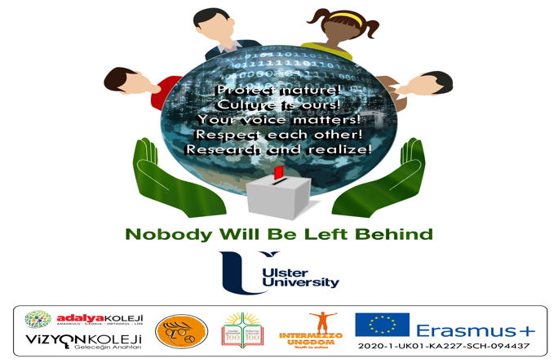

Promoting Citizenship Awareness amongst Young People in Europe using Education

European Youth and Culture Club Evaluation
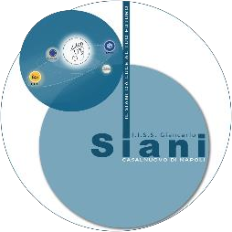
ISTITUTO SUPERIORE GIANCARLO SIANI

Contents

- Overview of European Youth and Culture Club use in your school

- Feedback from young people who were part European Youth and Culture Clubs

- Challenges engaging families and young people in European Youth and Culture Clubs

AIMS AND OBJECTIVES OF THE CURRENT REPORT

In this national report, we will capture how young people and families have engaged with the European Youth and Culture Clubs in your school and how effective this has been. The clubs are a key output of this project to help increase awareness and deliver citizenship education and this report allows an opportunity to present feedback on use.

- Overview of European Youth and Culture Club use in your school
  - This should provide details on how many young people and families engaged with this activity. The target for each school is 20 families and 50 young people.

- You should also comment on how well this was achieved and why?

The families involved were 15, the students 45-50. They all were interested and motivated.

- Feedback from young people who were part European Youth and Culture Clubs
Qualitative feedback from young people who used the European Youth and Culture Clubs as in testimonials. This is an opportunity to reflect in the young people’s own words how enjoyable, impactful, inspiring and beneficial the clubs were. Please include at least 5 testimonials.

Orsola (3rd year student) “I really liked this experience, and I’m looking forward to do it again.”
Flaviana (2nd year student) “I got to know students from other classes, had a lot of fun and learned interestng things.”
Francesco (2nd year student) “ It was nice to spend this time in a stress free context and make new friends. ”
Daniela (4th year student) “I loved it. Made new friends, got to know new and interesting things, improved my English.”
Miriam (3rd year student) “Great experience. I met a lot of new people and found that we have many things in common.”

3. What challenges did you face engaging families and young people in the European Youth and Culture Clubs
If no challenges then note ‘None’. If you found good practice that worked well then please share with other partners through this report.

The only challenge was to put down a time schedule that was appropriate for everyone.

